SIMATS ENGINEERING
ASSESSMENT TOOL 1

COURSE NAME: Database Management Systems
COURSE CODE: CSA0501

COURSE OUTCOME COVERED

CO3: Analyze relational databases using functional dependencies, normalization (1NF to 5NF), and key constraints to identify redundancy and ensure data integrity. (BL2, BL3)

Activity Tool : Experiments (High)
Assessment Tool Weightage: 40%

QUESTIONS Total Marks: 50
Q.No | Question | Bloom's Level | Marks
1 | For the relation STUDENT_COURSE(SID, SName, CID, CName, Instructor, Grade), identify all functional dependencies and determine the candidate keys. | BL2 – Understand | 5
2 | Demonstrate the process of converting an unnormalized relation into 1NF with step-by-step justification and example. | BL3 – Apply | 5
3 | Given relation R(A,B,C,D,E) with FDs: A→BC, BC→D, D→E. Analyze and decompose it to 2NF eliminating partial dependencies. | BL3 – Apply | 5
4 | Apply 3NF decomposition on the relation EMPLOYEE(EmpID, EmpName, DeptID, DeptName, ManagerID) with transitive dependencies. | BL3 – Apply | 5
5 | Verify whether R(A,B,C,D) with FDs: AB→C, C→D, D→A is in BCNF. If not, decompose it into BCNF. | BL3 – Apply | 5
6 | Experimentally verify lossless-join decomposition for a given relation using the tabular (Chase) algorithm. | BL3 – Apply | 5
7 | Identify the multi-valued dependencies in TEACHER(TID, Subject, Hobby) and decompose it into 4NF. | BL3 – Apply | 5
8 | Demonstrate how join dependencies lead to redundancy. Decompose a given relation to 5NF (Project-Join Normal Form). | BL3 – Apply | 5
9 | Given a poorly designed database schema for a college, identify all anomalies (insertion, deletion, update) and normalize it to 3NF. | BL2 – Understand | 5
10 | Compute the closure of attribute sets for the given FDs and determine all candidate keys for the relation. | BL3 – Apply | 5

Code of Conduct:

I K.SARANYA(192424409) (Name / Reg No) certify that this submission is my original work and that I have adhered to the guidelines specified for this assessment.
I understand that any violation of academic integrity rules will result in disciplinary action.

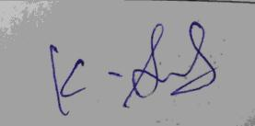
Signature of the student:

RUBRICS FOR CALCULATION:

Criteria | Weightage | Level 4 – Exemplary | Level 3 – Proficient | Level 2 – Developing | Level 1 – Beginning
Understanding of Concepts | 25 | Demonstrates thorough understanding and effectively integrates multiple concepts/technologies | Good understanding with proper integration of most concepts | Basic understanding; limited or partial integration | Poor understanding; unable to integrate concepts
Experimental Design | 30 | Well-planned, systematic implementation with optimal solution | Correct implementation with minor issues | Basic implementation with errors or inefficiencies | Incorrect or incomplete implementation
Use of Tools | 20 | Effective and advanced use of tools/technologies with proper configuration | Appropriate use of tools with correct execution | Limited or inconsistent use of tools | Incorrect or minimal use of tools
Analysis of Results | 15 | Insightful analysis with accurate interpretation and validation of results | Good analysis with reasonable interpretation | Basic analysis with limited insights | Poor or incorrect analysis of results
Documentation | 10 | Clear, well-structured documentation with diagrams, code, and results | Organized documentation with necessary details | Basic documentation with missing details | Poor or incomplete documentation

SIMATS ENGINEERING
ASSESSMENT TOOL 1 — SOLUTIONS

Table of Contents
Q1. Functional Dependencies & Candidate Keys — STUDENT_COURSE
Q2. Converting an Unnormalized Relation to 1NF
Q3. 2NF Decomposition of R(A,B,C,D,E)
Q4. 3NF Decomposition of EMPLOYEE
Q5. BCNF Verification and Decomposition of R(A,B,C,D)
Q6. Lossless-Join Verification using the Chase (Tabular) Algorithm
Q7. Multi-valued Dependencies and 4NF Decomposition — TEACHER
Q8. Join Dependency and 5NF (Project-Join Normal Form)
Q9. Anomalies and 3NF Normalization of a College Schema
Q10. Attribute Closure and Candidate Key Determination

QUESTION 1 | Functional Dependencies & Candidate Keys — STUDENT_COURSE
Relation: STUDENT_COURSE(SID, SName, CID, CName, Instructor, Grade)

Step 1: Assumptions
- Each student has a unique roll number SID, and each SID maps to exactly one SName.
- Each course has a unique code CID, and each CID maps to exactly one CName and exactly one Instructor.
- A student can enroll in many courses, and a course can have many students — so Grade is earned by a specific (student, course) pair.

Step 2: Identifying Functional Dependencies
# | Functional Dependency | Explanation
1 | SID → SName | A student ID uniquely determines the student's name.
2 | CID → CName | A course ID uniquely determines the course name.
3 | CID → Instructor | A course ID uniquely determines the instructor teaching it.
4 | SID, CID → Grade | The grade is assigned only for a specific student in a specific course.
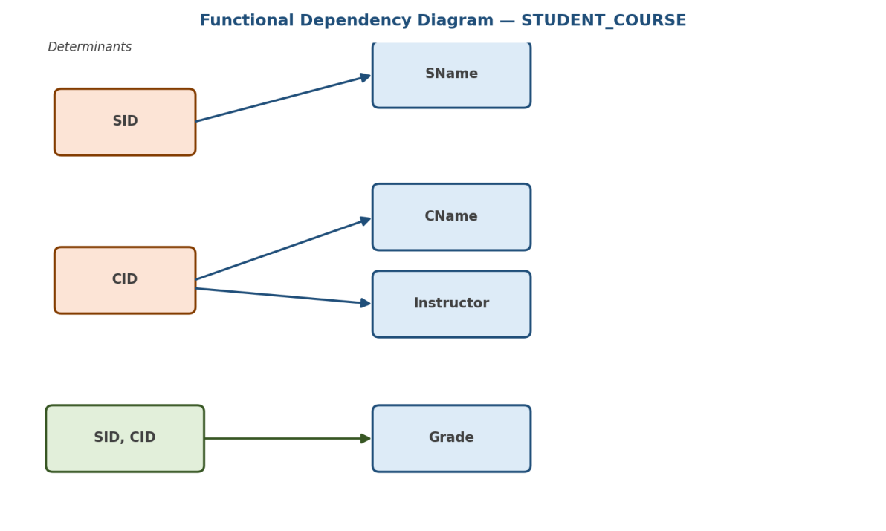
Figure 1.1 — Functional Dependency diagram for STUDENT_COURSE

Step 3: Determining the Candidate Key
To find the candidate key, compute the attribute closure of the combination {SID, CID}:
Closure Step | Working | Result
Start | {SID, CID} | {SID, CID}
Apply SID → SName | Add SName | {SID, CID, SName}
Apply CID → CName | Add CName | {SID, CID, SName, CName}
Apply CID → Instructor | Add Instructor | {SID, CID, SName, CName, Instructor}
Apply SID,CID → Grade | Add Grade | {SID, CID, SName, CName, Instructor, Grade} = ALL attributes
Since {SID, CID}⁺ equals the full attribute set of the relation, {SID, CID} is a super key. Testing the proper subsets:
- SID⁺ = {SID, SName} — does not cover all attributes ⇒ SID alone is not a key.
- CID⁺ = {CID, CName, Instructor} — does not cover all attributes ⇒ CID alone is not a key.
Since no proper subset of {SID, CID} is a super key, {SID, CID} is minimal.
Result: Candidate Key = {SID, CID} (Prime attributes: SID, CID | Non-prime: SName, CName, Instructor, Grade)

QUESTION 2 | Converting an Unnormalized Relation to 1NF
Goal: Demonstrate, step by step, how an unnormalized (UNF) relation containing repeating groups is converted into First Normal Form (1NF).

Step 1: Start with an Unnormalized Relation (UNF)
Consider a STUDENT_COURSE relation where a student can be enrolled in multiple courses. If all courses of a student are stored inside a single cell (a repeating group), the relation is unnormalized:
StudID | StudName | Courses (CID, CName)
S1 | Aarav | (C1, DBMS), (C2, Operating Systems)
S2 | Diya | (C3, Computer Networks)
Violation: The "Courses" column holds multiple (CID, CName) pairs in a single cell — this is a repeating group, so the relation is not atomic and violates 1NF.

Step 2: Rule for 1NF
- Every attribute must hold a single, atomic (indivisible) value.
- No repeating groups or multi-valued attributes are allowed within one row.
- Each row must be uniquely identifiable by a primary key.

Step 3: Remove Repeating Groups
Each value inside the repeating group is expanded into its own row, duplicating the atomic attributes (StudID, StudName) as needed. This is called "flattening":
StudID | StudName | CID | CName
S1 | Aarav | C1 | DBMS
S1 | Aarav | C2 | Operating Systems
S2 | Diya | C3 | Computer Networks

Step 4: Define the Primary Key for the 1NF Relation
After flattening, no single attribute uniquely identifies a row (StudID repeats). The composite key (StudID, CID) is required to uniquely identify each row:
1NF Relation: STUDENT_COURSE_1NF(StudID, StudName, CID, CName) — Primary Key = (StudID, CID)

Step 5: Justification
- Atomicity achieved — every cell (StudID, StudName, CID, CName) now holds exactly one value.
- No repeating groups remain — each course enrollment is its own row.
- A unique composite key (StudID, CID) exists to identify every row without ambiguity.
Note: This 1NF relation still contains a partial dependency (StudName depends only on StudID, part of the key) — this is resolved later in 2NF (see Q3/Q9).

QUESTION 3 | 2NF Decomposition of R(A,B,C,D,E)
Given: R(A, B, C, D, E) with FDs: A → BC, BC → D, D → E

Step 1: Determine the Candidate Key
Compute the closure of {A}:
Step | Apply FD | Closure so far
1 | Start | {A}
2 | A → BC | {A, B, C}
3 | BC → D | {A, B, C, D}
4 | D → E | {A, B, C, D, E} = all attributes of R
A⁺ = {A,B,C,D,E} = R, so {A} is a super key. Since no attribute other than A is missing from every right-hand side, A must belong to every candidate key, and since A alone is already a super key, {A} is minimal.
Candidate Key = {A} (single attribute).

Step 2: Check for Partial Dependency (2NF Test)
2NF is violated only when a non-prime attribute depends on a proper subset of a composite candidate key. Because the only candidate key here, {A}, is a single attribute, it has no non-empty proper subset — so a partial dependency is structurally impossible.
Conclusion: R already satisfies 2NF (no partial dependency exists).

Step 3: Going Further — Removing Transitive Dependencies (3NF)
Although 2NF is already satisfied, the FD chain A → BC → D → E contains transitive dependencies (D and E depend on A only indirectly, through BC and D). For a fully normalized, redundancy-free design we decompose using the 3NF synthesis algorithm — one relation per FD:
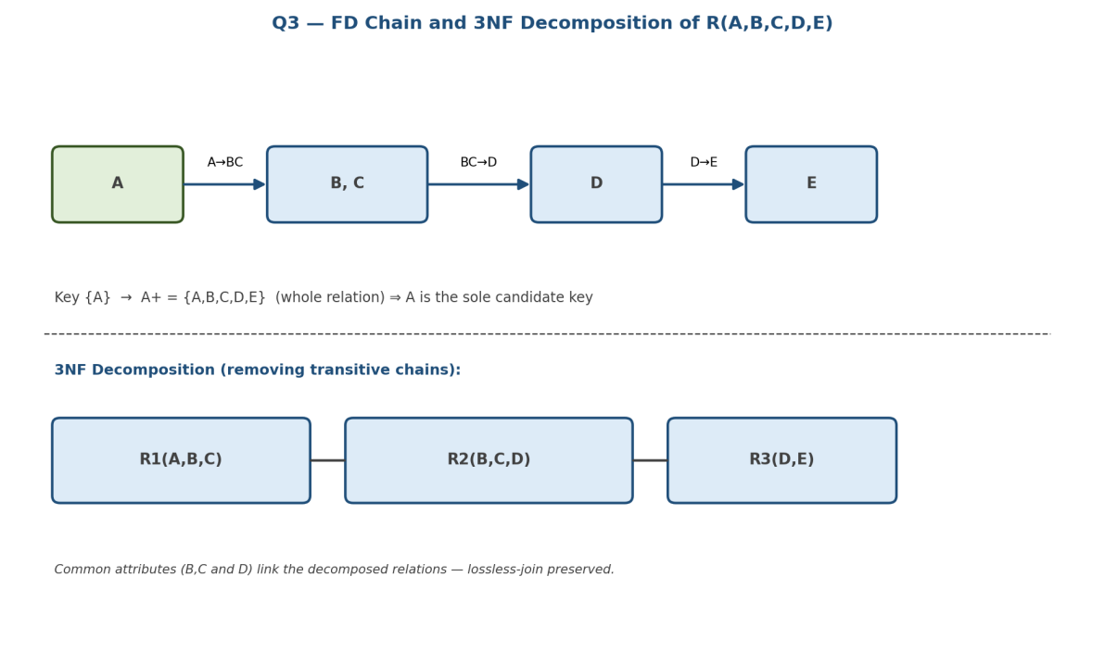
Figure 3.1 — FD chain and resulting decomposition of R(A,B,C,D,E)
Decomposed Relation | Source FD | Key
R1(A, B, C) | A → BC | A
R2(B, C, D) | BC → D | B, C
R3(D, E) | D → E | D
This decomposition is lossless-join (each pair of relations shares a common attribute set that is a key in one of them: {B,C} links R1–R2, {D} links R2–R3) and dependency-preserving (every original FD is enforceable within one of R1, R2, R3).

QUESTION 4 | 3NF Decomposition of EMPLOYEE
Given: EMPLOYEE(EmpID, EmpName, DeptID, DeptName, ManagerID)

Step 1: Identify Functional Dependencies
# | FD | Type
1 | EmpID → EmpName, DeptID, ManagerID | Key-based (direct)
2 | DeptID → DeptName | Transitive (via DeptID)

Step 2: Determine the Candidate Key
EmpID⁺ = {EmpID, EmpName, DeptID, ManagerID, DeptName} = all attributes (DeptName is reached transitively through DeptID → DeptName). Hence Candidate Key = {EmpID}.

Step 3: Check for Transitive Dependency (3NF Test)
A relation violates 3NF when a non-prime attribute is transitively dependent on the candidate key through another non-prime attribute. Here:
- EmpID → DeptID (DeptID is non-prime)
- DeptID → DeptName (DeptName is non-prime)
- Therefore EmpID → DeptID → DeptName is a transitive dependency ⇒ EMPLOYEE violates 3NF.
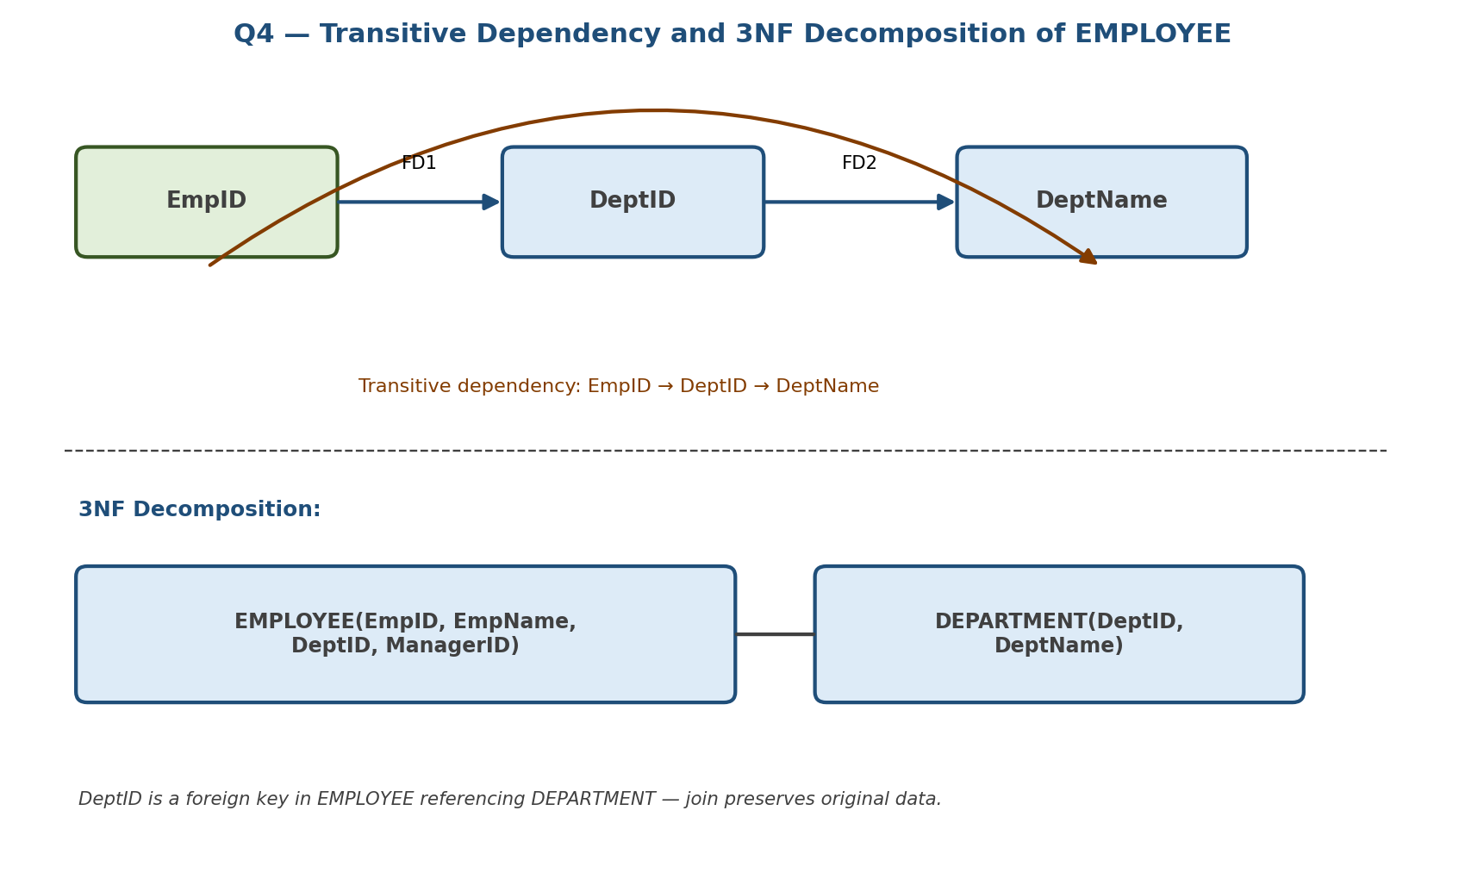
Figure 4.1 — Transitive dependency and 3NF decomposition of EMPLOYEE

Step 4: 3NF Decomposition
Decomposed Relation | Primary Key | Foreign Key
EMPLOYEE(EmpID, EmpName, DeptID, ManagerID) | EmpID | DeptID → DEPARTMENT(DeptID)
DEPARTMENT(DeptID, DeptName) | DeptID | —
Lossless-join: DeptID is common to both relations and is a candidate key of DEPARTMENT, satisfying the lossless-join decomposition condition R1 ∩ R2 → R2 (or R1). Dependency-preserving: both original FDs are enforceable locally within one of the two relations.

QUESTION 5 | BCNF Verification and Decomposition of R(A,B,C,D)
Given: R(A, B, C, D) with FDs: AB → C, C → D, D → A

Step 1: Determine All Candidate Keys
Since B never appears on the right-hand side of any FD, B must be part of every candidate key. Testing combinations that include B:
Attribute Set | Closure Computation | Super key?
AB | AB → C gives {A,B,C}; C → D gives {A,B,C,D} = R | Yes — minimal (A alone, B alone fail)
BC | C → D gives {B,C,D}; D → A gives {A,B,C,D} = R | Yes — minimal
BD | D → A gives {A,B,D}; AB → C gives {A,B,C,D} = R | Yes — minimal
Candidate Keys = {A,B}, {B,C}, {B,D}. Prime attributes: A, B, C, D (all attributes are prime, since each appears in at least one key).

Step 2: Check BCNF Condition
BCNF requires that for every non-trivial FD X → Y, X must be a super key (this is stricter than 3NF, which allows Y to be prime instead).
FD | Is LHS a super key? | BCNF Verdict
AB → C | Yes — {A,B} is a candidate key | Satisfies BCNF
C → D | No — C⁺ = {A,C,D}, missing B | Violates BCNF
D → A | No — D⁺ = {A,D}, missing B,C | Violates BCNF
Conclusion: R is NOT in BCNF, since C → D and D → A both have determinants that are not super keys.

Step 3: Recursive BCNF Decomposition
Apply the standard BCNF decomposition algorithm, splitting on a violating FD at each step.
- Split R on C → D: R1(A, C, D) and R2(B, C).
- Check R1(A,C,D): FD D → A still has D⁺ = {A,D} within R1, missing C ⇒ still violates BCNF.
- Split R1 on D → A: R1a(A, D) and R1b(C, D).
- R1a(A,D): D → A, D is the key of R1a ⇒ BCNF. R1b(C,D): C → D, C is the key of R1b ⇒ BCNF. R2(B,C): no non-trivial FD holds ⇒ BCNF (trivially).
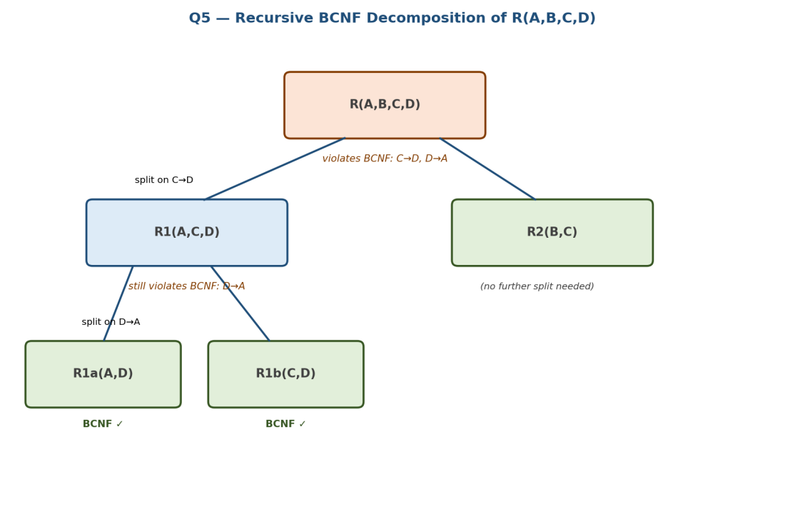
Figure 5.1 — Recursive BCNF decomposition tree for R(A,B,C,D)

Step 4: Final BCNF Schema
Relation | Key | Holding FD
R1a(A, D) | D | D → A
R1b(C, D) | C | C → D
R2(B, C) | {B,C} | (no non-trivial FD)
Trade-off: This decomposition is lossless-join, but it is not dependency-preserving — the original FD AB → C cannot be verified from any single decomposed relation and would require joining R1b and R2 to check. This is a well-known limitation of BCNF decomposition versus 3NF.

QUESTION 6 | Lossless-Join Verification using the Chase (Tabular) Algorithm
Given: R(A, B, C, D) with FD: A → B. Decomposition ρ = { R1(A, B), R2(A, C, D) }

Step 1: Purpose of the Chase Algorithm
The chase (tabular / tableau) algorithm experimentally verifies whether a decomposition is lossless-join: joining the decomposed relations must reproduce exactly the original relation, with no spurious tuples. A decomposition is lossless-join if, after applying every FD to the tableau, at least one row becomes composed entirely of unsubscripted "a" symbols (i.e., it matches R's own tuple).

Step 2: Construct the Initial Tableau
Create one row per relation in the decomposition. For each attribute, use ai (unsubscripted) if the attribute belongs to that relation's projection, otherwise use a distinct "b" symbol.
Row (Relation) | A | B | C | D
Row 1 — R1(A,B) | a1 | a2 | b13 | b14
Row 2 — R2(A,C,D) | a1 | b22 | a3 | a4

Step 3: Apply Functional Dependencies
Apply A → B: both rows agree on column A (both have a1), so by the FD, they must also agree on column B. Row 2's value (b22) is changed to match Row 1's value (a2):
Row (Relation) | A | B | C | D
Row 1 — R1(A,B) | a1 | a2 | b13 | b14
Row 2 — R2(A,C,D) | a1 | a2 | a3 | a4

Step 4: Interpret the Result
After applying all FDs in F, Row 2 becomes (a1, a2, a3, a4) — entirely unsubscripted "a" symbols. This means Row 2 represents a tuple identical to a tuple of the original relation R.
Conclusion: Since an all-"a" row was produced, ρ = {R1(A,B), R2(A,C,D)} is a LOSSLESS-JOIN decomposition of R with respect to F = {A → B}.

Step 5: General Rule (Two-Relation Shortcut)
For a decomposition into exactly two relations R1 and R2, the chase result matches this simpler lossless-join test:
- ρ = {R1, R2} is lossless-join if and only if (R1 ∩ R2) → R1 or (R1 ∩ R2) → R2 holds in F+.
- Here, R1 ∩ R2 = {A}, and A → B means A → R1 (since R1 = A,B) — confirming the same lossless-join result obtained via the chase table.

QUESTION 7 | Multi-valued Dependencies and 4NF Decomposition — TEACHER
Given: TEACHER(TID, Subject, Hobby)

Step 1: Understand the Scenario
A teacher can teach multiple subjects and independently pursue multiple hobbies. Subject and Hobby have no direct relationship with each other — they are two independent multi-valued facts about the same TID. There is no functional dependency here (no single-valued determinacy); instead, the relation exhibits multi-valued dependencies (MVDs).

Step 2: Identify the Multi-valued Dependencies
MVD | Meaning
TID →→ Subject | For a given TID, the set of Subject values is independent of Hobby values.
TID →→ Hobby | For a given TID, the set of Hobby values is independent of Subject values.

Step 3: Illustrate the Redundancy (4NF Violation)
Suppose Teacher T1 teaches {DBMS, Operating Systems} and has hobbies {Reading, Painting}. Because Subject and Hobby are independent, every subject must be paired with every hobby to avoid losing information — producing a Cartesian-product-like redundancy:
TID | Subject | Hobby
T1 | DBMS | Reading
T1 | DBMS | Painting
T1 | Operating Systems | Reading
T1 | Operating Systems | Painting
Violation: 4 rows are needed to represent just 2 subjects and 2 hobbies — this redundancy is the hallmark of a 4NF violation caused by two independent MVDs on the same relation.

Step 4: Decompose into 4NF
4NF requires that every non-trivial MVD X →→ Y has X as a super key. We resolve this by splitting the independent multi-valued facts into separate relations:
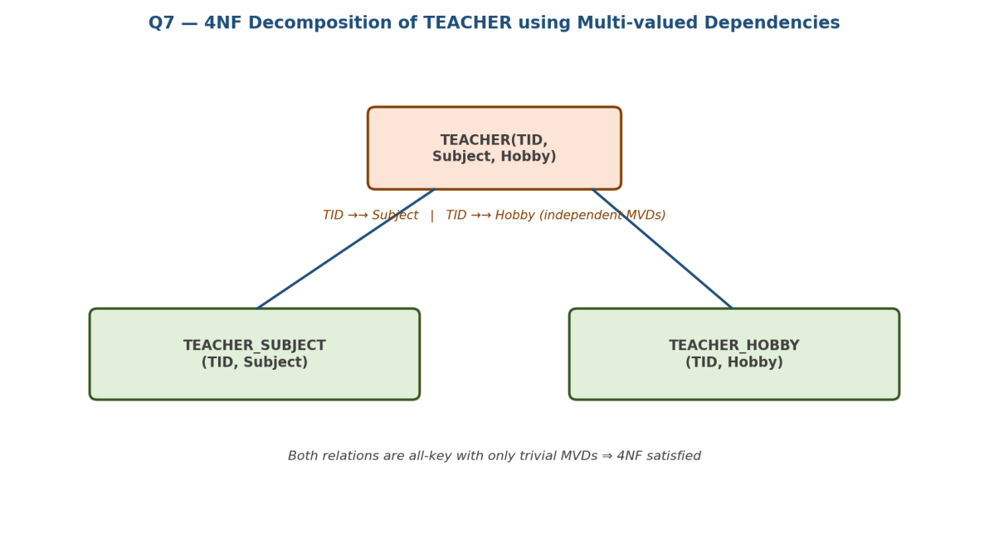
Figure 7.1 — 4NF decomposition of TEACHER
Decomposed Relation | Rows for T1 example
TEACHER_SUBJECT(TID, Subject) | (T1,DBMS), (T1,Operating Systems)
TEACHER_HOBBY(TID, Hobby) | (T1,Reading), (T1,Painting)
Both relations are now "all-key" with only trivial MVDs, so they satisfy 4NF. The redundant 4-row Cartesian combination is eliminated (2+2 = 4 rows total instead of 4 redundant rows), and the join of the two relations reconstructs the original data losslessly.

QUESTION 8 | Join Dependency and 5NF (Project-Join Normal Form)
Given: SUPPLY(Supplier, Part, Project)

Step 1: What Causes 5NF Violations
A relation can fail to be in 5NF even after satisfying BCNF and 4NF, if it is subject to a join dependency (JD) that is not implied by its candidate keys. A join dependency *(R1, R2, ..., Rn) states that R is exactly reconstructable by joining its projections R1,...,Rn — but is not reconstructable from any smaller subset of those projections.

Step 2: The Classic Ternary-Relationship Example
SUPPLY(Supplier, Part, Project) records that a Supplier supplies a Part for a Project — but suppose the business rule is actually three independent pairwise facts: (a) which suppliers can supply which parts, (b) which parts are needed by which projects, and (c) which suppliers work on which projects. If a (Supplier,Part,Project) row exists only when all three pairwise facts independently hold, this is a join dependency:
JD: *( (Supplier, Part), (Part, Project), (Supplier, Project) )
If SUPPLY is kept as one ternary table, storing this three-way relationship directly causes update/insert redundancy — the same pairwise fact must be repeated across many rows.
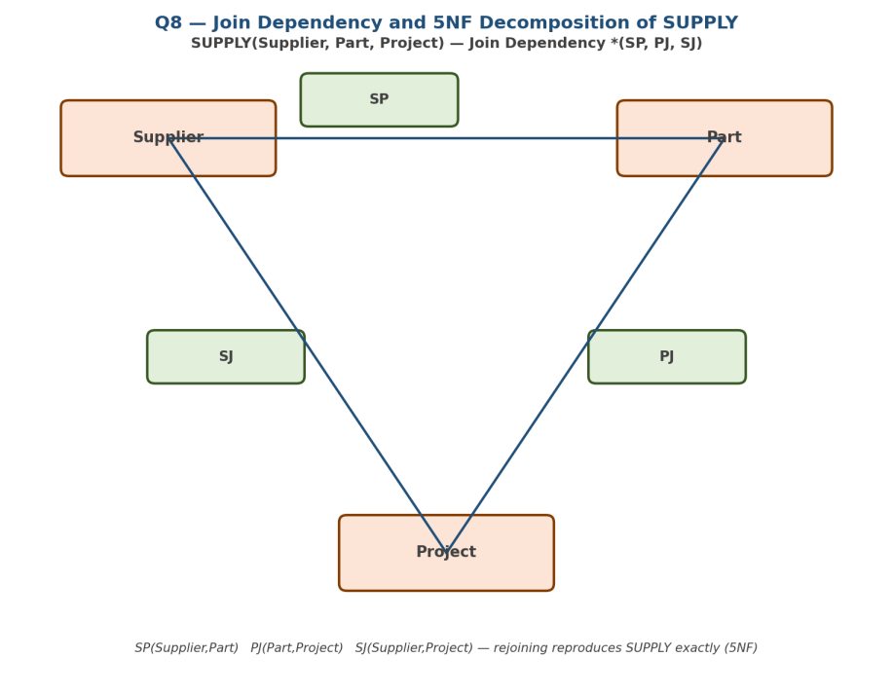
Figure 8.1 — Join dependency and 5NF decomposition of SUPPLY

Step 3: Decompose to 5NF
Decomposed Relation | Represents
SP(Supplier, Part) | Which suppliers can supply which parts
PJ(Part, Project) | Which parts are required by which projects
SJ(Supplier, Project) | Which suppliers are associated with which projects
SUPPLY = SP ⋈ PJ ⋈ SJ reconstructs the original relation exactly, with no spurious tuples, because the join dependency holds. No further nonloss decomposition of SP, PJ, or SJ is possible — each is already in 5NF (Project-Join Normal Form).
Test for necessity: If SUPPLY could instead be reconstructed correctly by joining just two of the three projections, then the ternary join dependency would not genuinely hold, and the 3-way split would be unnecessary. Here all three are required, confirming a genuine 5NF violation in the original table.

QUESTION 9 | Anomalies and 3NF Normalization of a College Schema
Given (poorly designed): COLLEGE_DATA(StudID, StudName, DeptID, DeptName, HOD, CourseID, CourseName, Credits, Marks)

Step 1: Sample Data (Illustrating the Problem)
StudID | StudName | DeptID | DeptName | HOD | CourseID | CourseName | Marks
S1 | Aarav | D1 | CSE | Dr. Rao | C1 | DBMS | 88
S1 | Aarav | D1 | CSE | Dr. Rao | C2 | OS | 75
S2 | Diya | D1 | CSE | Dr. Rao | C1 | DBMS | 91
S3 | Kabir | D2 | ECE | Dr. Iyer | C3 | Signals | 80

Step 2: Identify the Anomalies
Anomaly Type | Example from the Table | Explanation
Insertion Anomaly | Cannot record a new department (e.g., D3, IT, Dr. Sen) until at least one student from that department enrolls in a course. | Department and course details are not stored independently of student enrollment.
Deletion Anomaly | Deleting student S3's only row deletes all information about department D2 (ECE, Dr. Iyer) and course C3 (Signals) as well. | Unrelated facts are destroyed as a side effect of removing one enrollment fact.
Update Anomaly | If Dr. Rao is replaced as HOD of D1, every row with DeptID = D1 must be updated individually. | Repeated storage of DeptName/HOD across many rows risks inconsistency if not all copies are updated.

Step 3: Identify Functional Dependencies
# | FD | Type
1 | StudID → StudName, DeptID | Partial (depends on part of composite key)
2 | DeptID → DeptName, HOD | Transitive (via DeptID)
3 | CourseID → CourseName, Credits | Partial (depends on part of composite key)
4 | StudID, CourseID → Marks | Full functional dependency on composite key
Candidate Key of COLLEGE_DATA = {StudID, CourseID}.
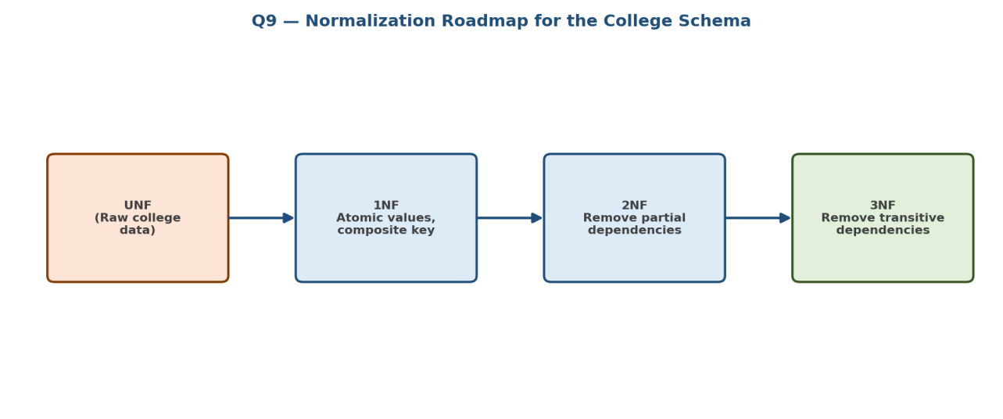
Figure 9.1 — Normalization roadmap applied to the college schema

Step 4: Normalize to 2NF (Remove Partial Dependencies)
StudName/DeptID depend only on StudID (part of the key), and CourseName/Credits depend only on CourseID (part of the key) — both are partial dependencies. Split them out:
Relation (2NF) | Key
STUDENT(StudID, StudName, DeptID) | StudID
COURSE(CourseID, CourseName, Credits) | CourseID
ENROLLMENT(StudID, CourseID, Marks) | {StudID, CourseID}

Step 5: Normalize to 3NF (Remove Transitive Dependencies)
Within STUDENT, DeptID → DeptName, HOD is a transitive dependency (StudID → DeptID → DeptName/HOD). Split it out:
Final 3NF Relation | Key |  | Foreign Key
STUDENT(StudID, StudName, DeptID) | StudID |  | DeptID → DEPARTMENT
DEPARTMENT(DeptID, DeptName, HOD) | DeptID |  | —
COURSE(CourseID, CourseName, Credits) | CourseID |  | —
ENROLLMENT(StudID, CourseID, Marks) | {StudID, CourseID} |  | StudID → STUDENT, CourseID → COURSE
Result: All insertion, deletion, and update anomalies are eliminated — departments and courses can now be added, removed, or updated independently of student enrollment records.

QUESTION 10 | Attribute Closure and Candidate Key Determination
Given: R(A, B, C, D, E) with FD set F = { A → BC, B → D, CD → E, E → A }

Step 1: The Closure Algorithm
The closure X⁺ of an attribute set X (under FD set F) is computed by repeatedly adding the right-hand side of any FD whose left-hand side is already contained in the closure, until no further attributes can be added.

Step 2: Compute A⁺
Iteration | FD Applied | Closure
0 | — | {A}
1 | A → BC | {A, B, C}
2 | B → D | {A, B, C, D}
3 | CD → E | {A, B, C, D, E} = R
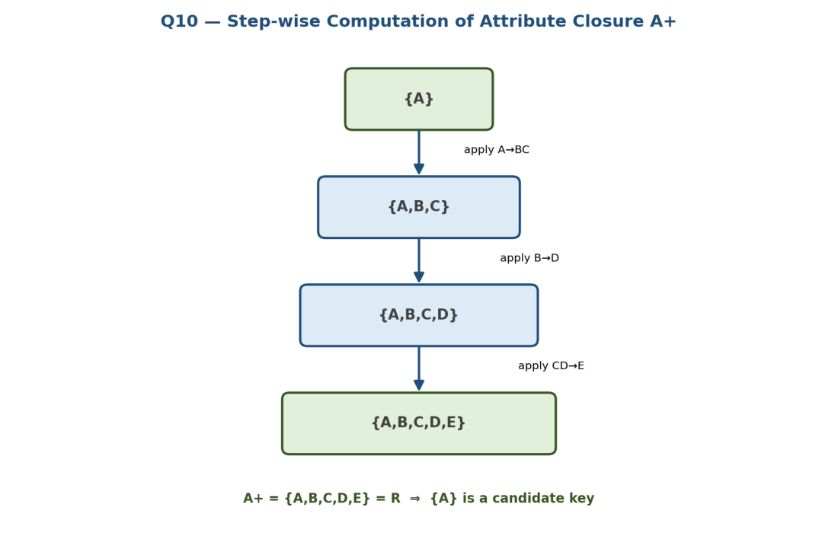
Figure 10.1 — Step-wise closure computation for A+
Since A⁺ = R, {A} is a super key. As a single attribute it is trivially minimal, so {A} is a candidate key.

Step 3: Compute E⁺ (Check for Additional Candidate Keys)
Iteration | FD Applied | Closure
0 | — | {E}
1 | E → A | {A, E}
2 | A → BC | {A, B, C, E}
3 | B → D | {A, B, C, D, E} = R
Since E⁺ = R, {E} is also a candidate key.

Step 4: Verify Remaining Single Attributes Are Not Keys
Attribute | Closure | Covers all of R?
B⁺ | {B, D} | No
C⁺ | {C} | No
D⁺ | {D} | No
Final Result: Candidate Keys = {A} and {E}. Prime attributes: A, E. Non-prime attributes: B, C, D.

